**PRESENTATION**

*Mother's Day in USA*

Prepared by

Student of FEI – 12

Vira Lytvyn

Teacher

O. Shums’ka

Lviv 2011

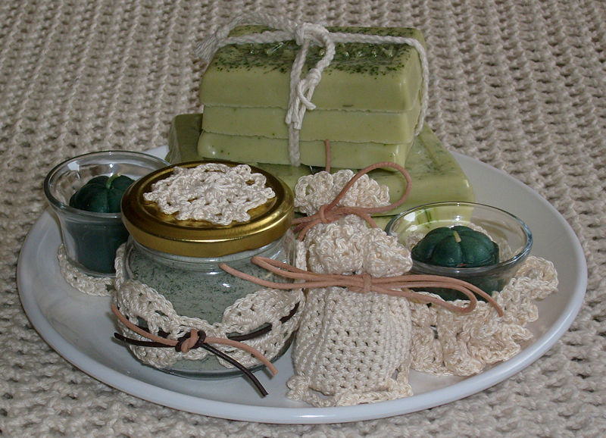Examples of handmade Mother's Day gifts.**↓**

Mother's Day is an annual holiday that recognizes mothers, motherhood and maternal bonds in general, as well the positive contributions that they make to society. In the United States it is celebrated on the second Sunday in

***First attempts to establish a holiday***

**←**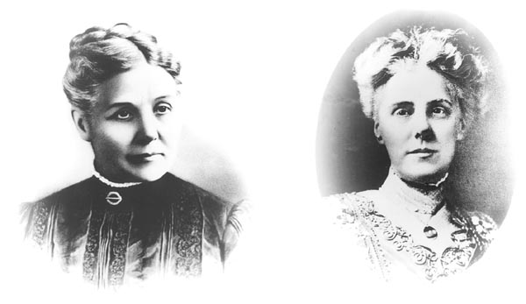Ann Maria Reeves Jarvis and daughter Anna

In a former incarnation "Mother's Day" in the U.S. was mostly marked by women's peace groups. A common early activity was the meeting of groups of mothers whose sons had fought or died on opposite sides of the American Civil War. There were several limited observances in the 1870s and the 1880s but none achieved resonance beyond the local level.

In 1868 Ann Jarvis created a committee to establish a "Mother's Friendship Day" whose purpose was "to reunite families that had been divided during the Civil War", and she wanted to expand it into an annual memorial for mothers, but she died in 1905 before the celebration became popular. Her daughter Anna Jarvis would continue her mother's efforts.

In New York City, Julia Ward Howe led a "Mother's Day" anti-war observance on June 2, 1872, which was accompanied by a Mother's Day Proclamation. The observance continued in Boston for about 10 years under Howe's personal sponsorship, then died out.

Frank E. Hering, President of the Fraternal Order of Eagles, made the first known public plea for "a national day to honor our mothers" in 1904.

***Holiday establishment***

In its present form, Mother's Day was established by Anna Marie Jarvis, following the death of her mother Ann Jarvis on May 9, 1905, with the help of Philadelphia merchant John Wanamaker. A small service was held on May 12, 1907 in the Andrew's Methodist Episcopal Church in Grafton, West Virginia where Anna's mother had been teaching Sunday school. But the first "official" service was on May 10, 1908 in the same church, accompanied by a larger ceremony in the Wanamaker Auditorium in the Wanamaker's store on Philadelphia. She then campaigned to establish Mother's Day first as a U.S. national holiday and then later as an international holiday..

The holiday was declared officially by the state of West Virginia in 1910, and the rest of states followed quickly. On May 8, 1914, the U.S. Congress passed a law designating the second Sunday in May as Mother's Day and requesting a proclamation. On May 9, 1914 President Woodrow Wilson issued a proclamation declaring the first national Mother's Day as a day for American citizens to show the flag in honor of those mothers whose sons had died in war.

In 1934, U.S. President Franklin D. Roosevelt approved a stamp commemorating the holiday.

In May 2008 the U.S. House of Representatives voted twice on a resolution commemorating Mother's Day, the first one being unanimous (with 21 members not voting). The Grafton's church, where the first celebration was held, is now the International Mother's Day Shrine and is a National Historic Landmark.

***Carnations***

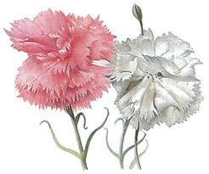Carnations have come to represent Mother's Day, since Anna Jarvis delivered 500 of them at its first celebration in 1908. Many religious services held later copied the custom of giving away carnations. This also started the custom of wearing a carnation on Mother's Day. The founder, Anna Jarvis, chose the carnation because it was the favorite flower of her mother. In part due to the shortage of white carnations, and in part due to the efforts to expand the sales of more types of flowers in Mother's Day, the florists promoted wearing a red carnation if your mother was living, or a white one if she was dead; this was tirelessly promoted until it made its way into the popular observations at churches.

***Commercialization***

Nine years after the first official Mother's Day, commercialization of the U.S. holiday became so rampant that Anna Jarvis herself became a major opponent of what the holiday had become and spent all her inheritance and the rest of her life fighting what she saw as an abuse of the celebration.

Later commercial and other exploitations of the use of Mother's Day infuriated Anna and she made her criticisms explicitly known throughout her time. She criticized the practice of purchasing greeting cards, which she saw as a sign of being too lazy to write a personal letter. She was arrested in 1948 for disturbing the peace while protesting against the commercialization of Mother's Day, and she finally said that she "wished she would have never started the day because it became so out of control ...".

Mother's Day continues to be one of the most commercially successful U.S. occasions. According to the National Restaurant Association, Mother's Day is now the most popular day of the year to dine out at a restaurant in the United States.

For example, according to IBIS World, a publisher of business research, Americans will spend approximately $2.6 billion on flowers, $1.53 billion on pampering gifts—like spa treatments—and another $68 million on greeting cards.

Mother's Day will generate about 7.8% of the U.S. jewelry industry's annual revenue in 2008, with custom gifts like mother's rings.

It's possible that the holiday would have withered over time without the support and continuous promotion of the florist industries and other commercial industries. Other Protestant holidays from the same time, like Children's Day and Temperance Sunday, do not have the same level of popularity. Mother's Day is also prominent in the Sunday Funnies of the United States, being a rich source of humor concerning mothers, children and husbands ranging from sentimental to wry to caustic.